LIVE CHAT:

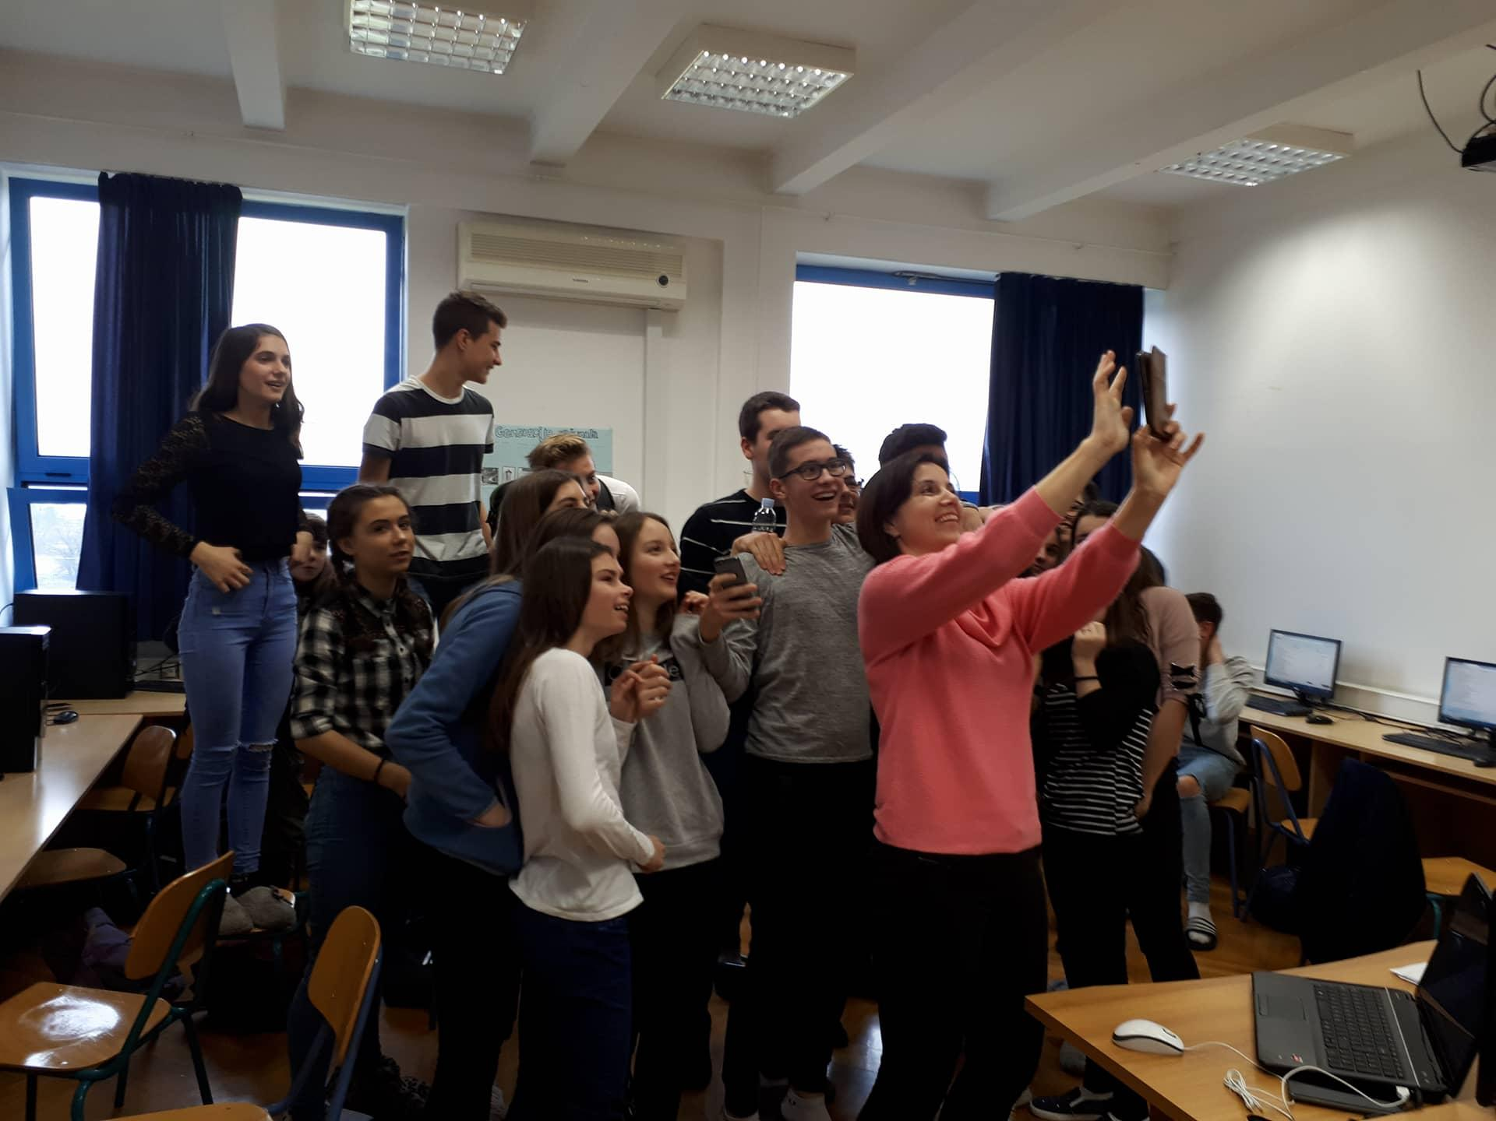 Croatian Students
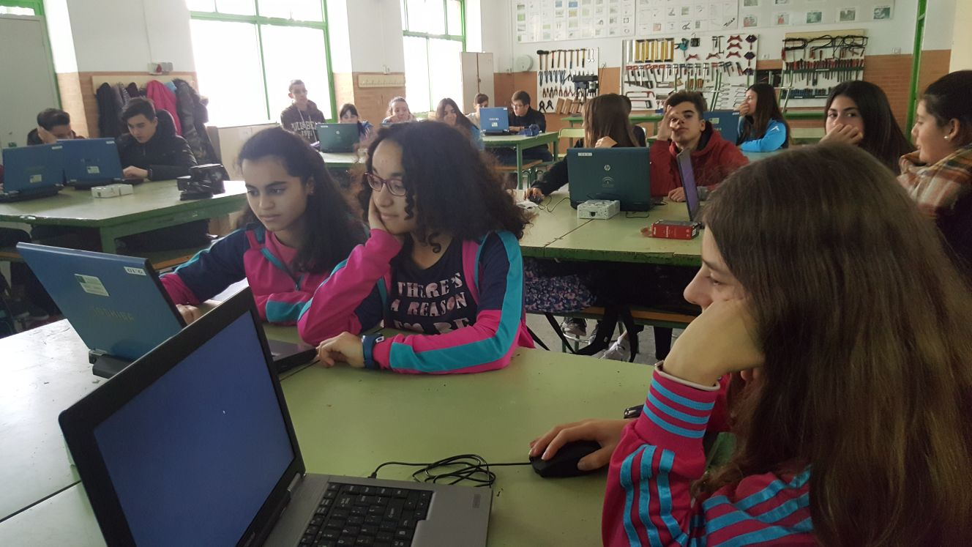 Spanish students

1. Embed code za padlet

<div class="padlet-embed" style="border:1px solid rgba(0,0,0,0.1);border-radius:2px;box-sizing:border-box;overflow:hidden;position:relative;width:100%;background:#F4F4F4"><p style="padding:0;margin:0"><iframe src="https://padlet.com/embed/e0h4s9ouv1s7" frameborder="0" style="width:100%;height:608px;display:block;padding:0;margin:0"></iframe></p><div style="padding:8px;text-align:right;margin:0;"><a href="https://padlet.com?ref=embed" style="padding:0;margin:0;border:none;display:block;line-height:1;height:16px" target="_blank"><img src="https://resources.padletcdn.com/assets/made_with_padlet.png" width="86" height="16" style="padding:0;margin:0;background:none;border:none;display:inline;box-shadow:none" alt="Made with Padlet"></a></div></div>

Padlet: Food as Cultural Heritage (Hrana kao kulturno nasljeđe) (https://padlet.com/hkraljik/e0h4s9ouv1s7)

2. Embed code za Thinglink

<img style="max-width:100%" src="//cdn.thinglink.me/api/image/982284908019843075/1024/10/scaletowidth#tl-982284908019843075;'" class="alwaysThinglink"/><script async charset="utf-8" src="//cdn.thinglink.me/jse/embed.js"></script>

Thinglink: Autumn in Zaprešić (Jesen u Zaprešiću) (https://www.thinglink.com/scene/982284908019843075)

3. Kahoot! - Traditional Croatian Food (https://play.kahoot.it/#/k/27da6c9a-58fd-4afe-ad72-0c70bc0df1a6)

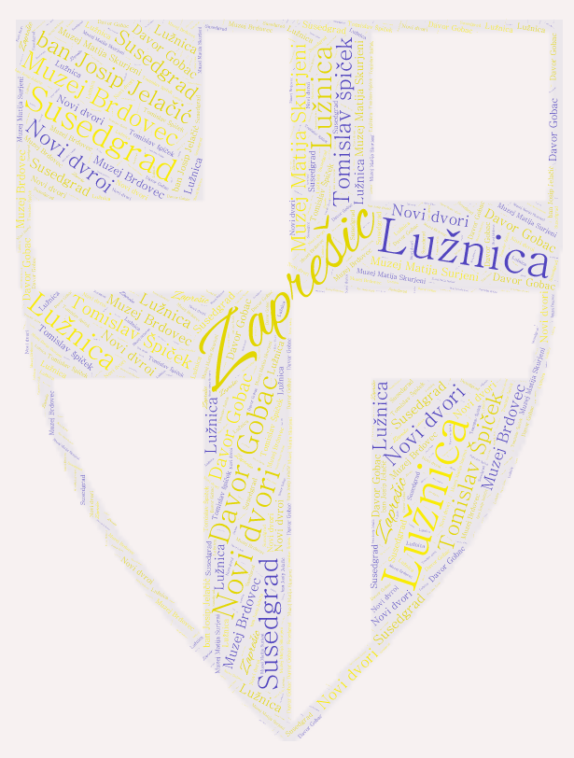 4. WordCloud: Zaprešić
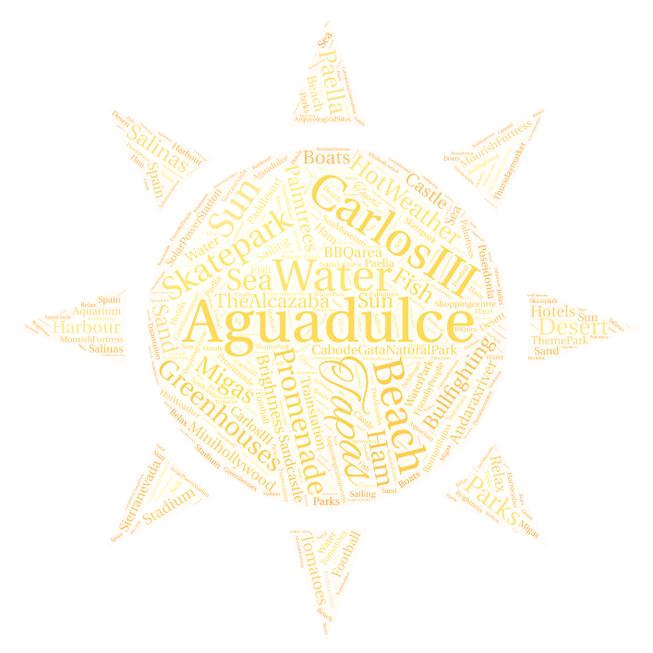5. WordCloud: Aguadulce

