Rezultati istraživanja o urođenim i usvojenim sklonostima ka poduzetničkom ponašanju

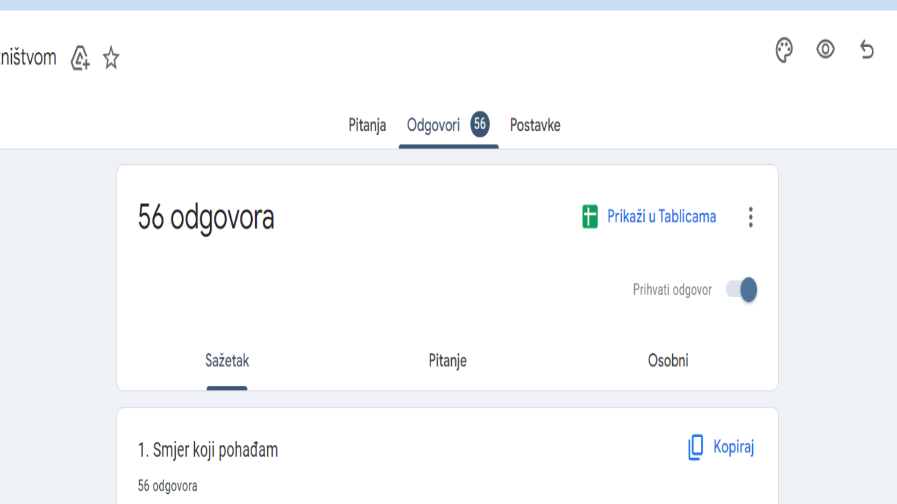

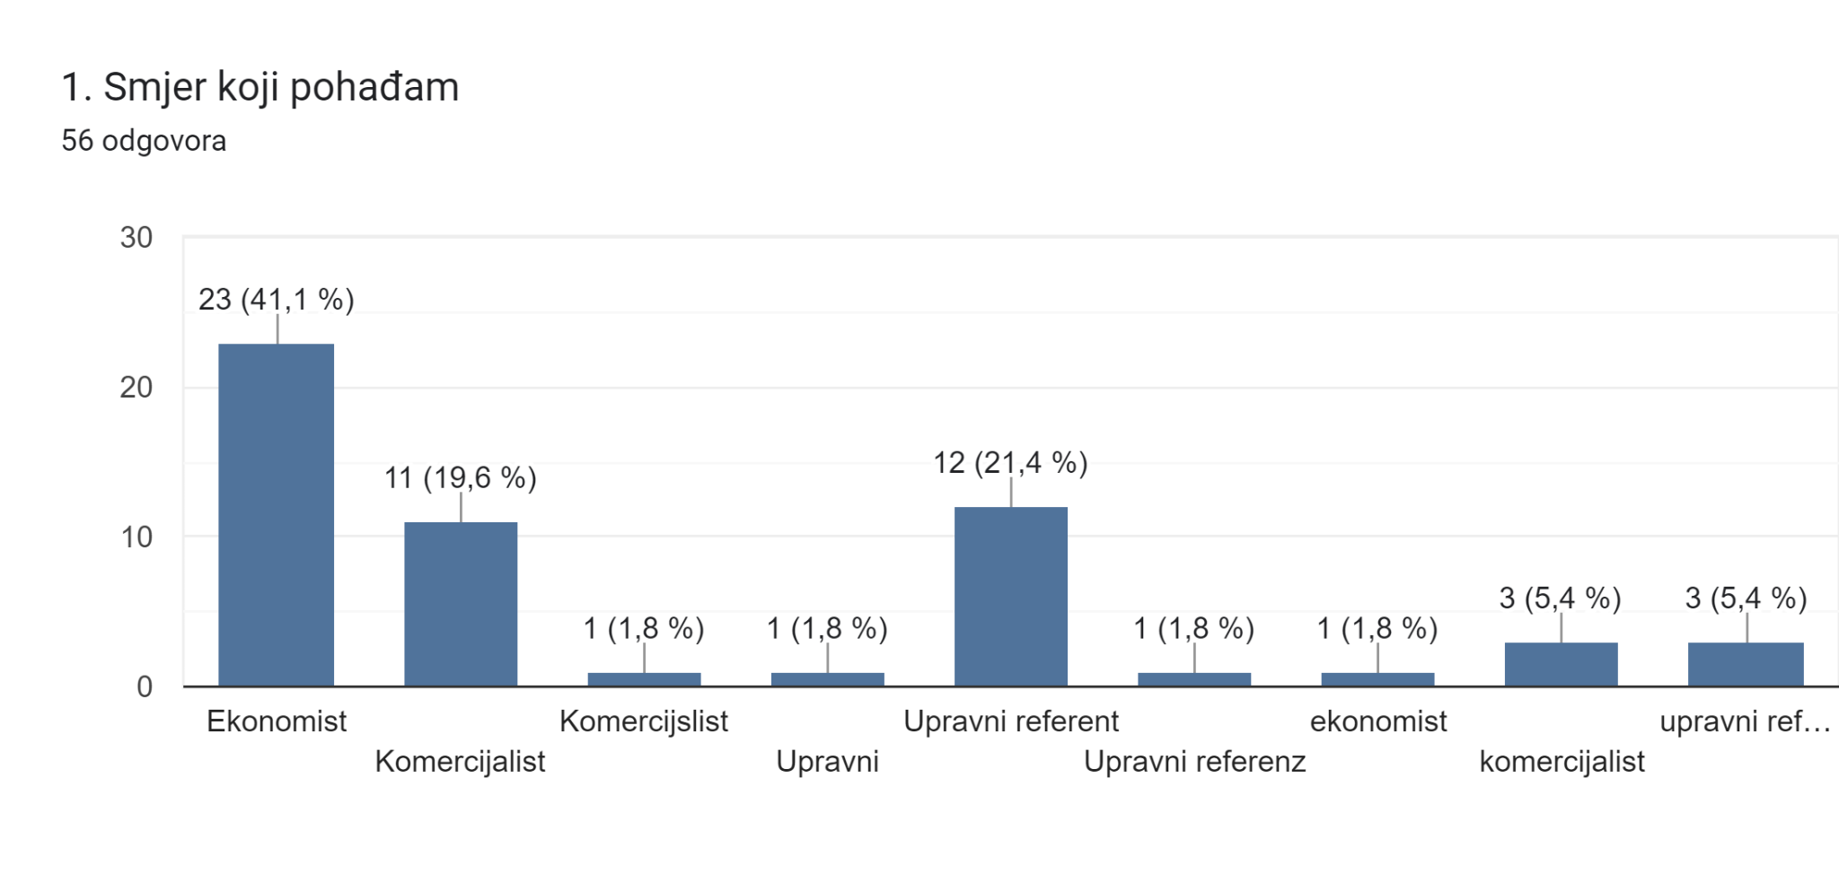[1]

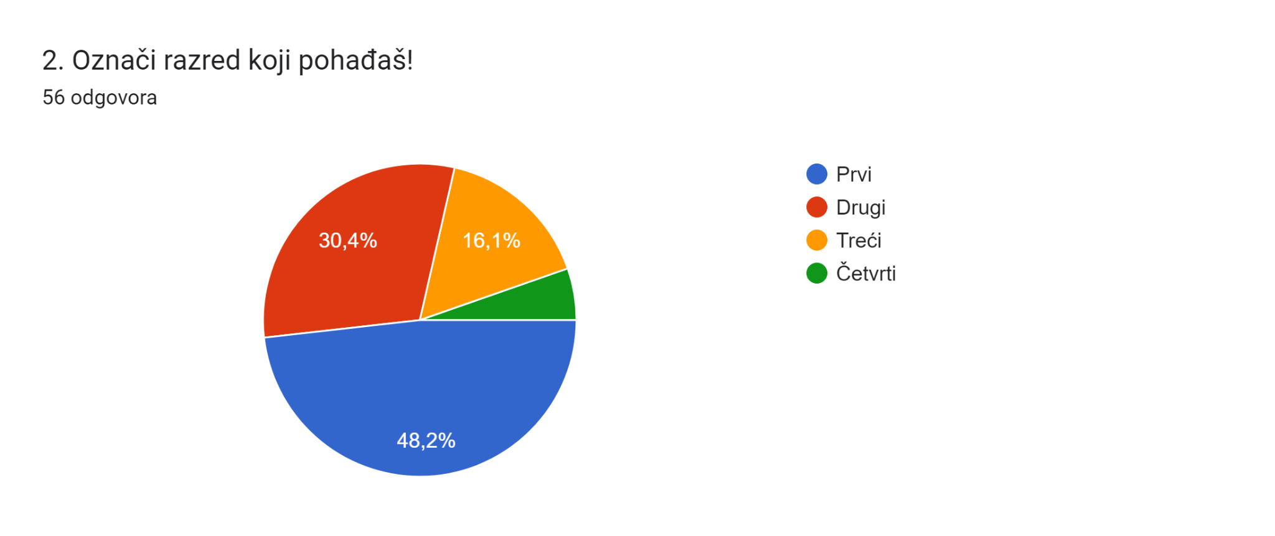

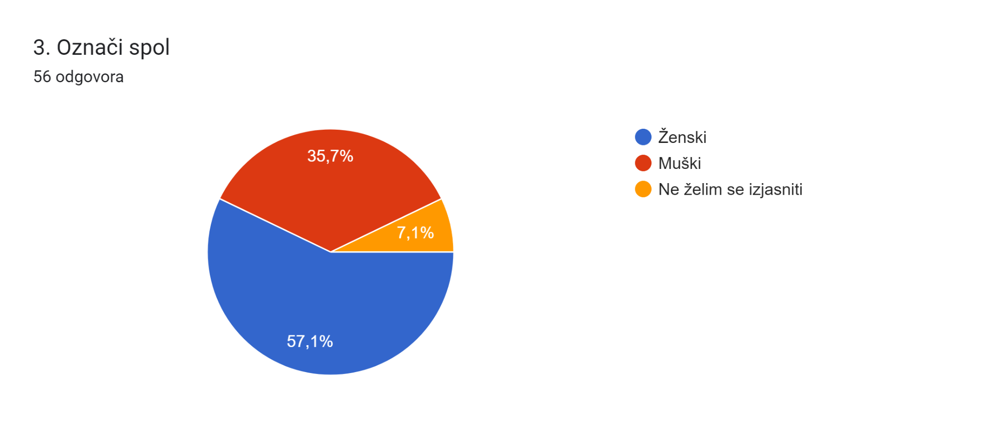

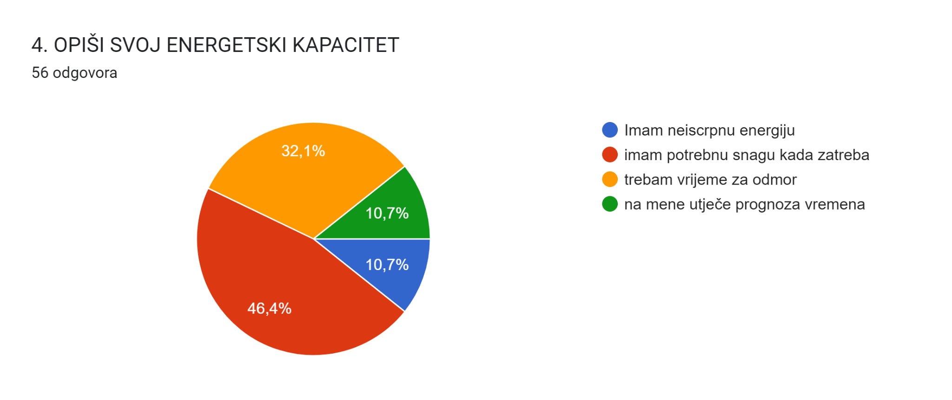[2]

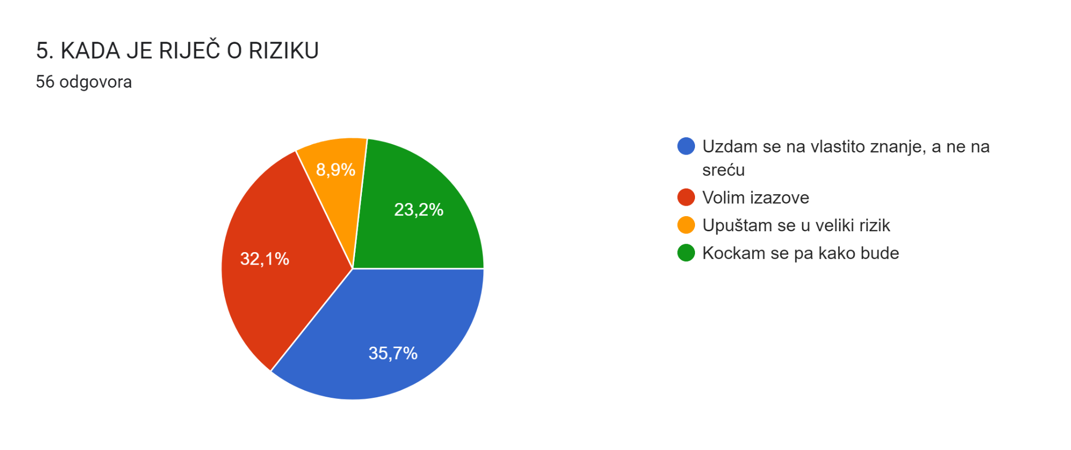

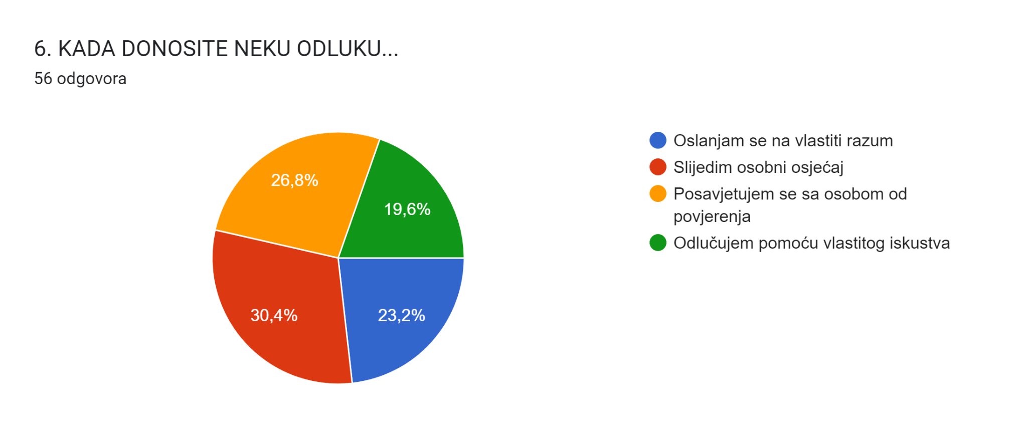

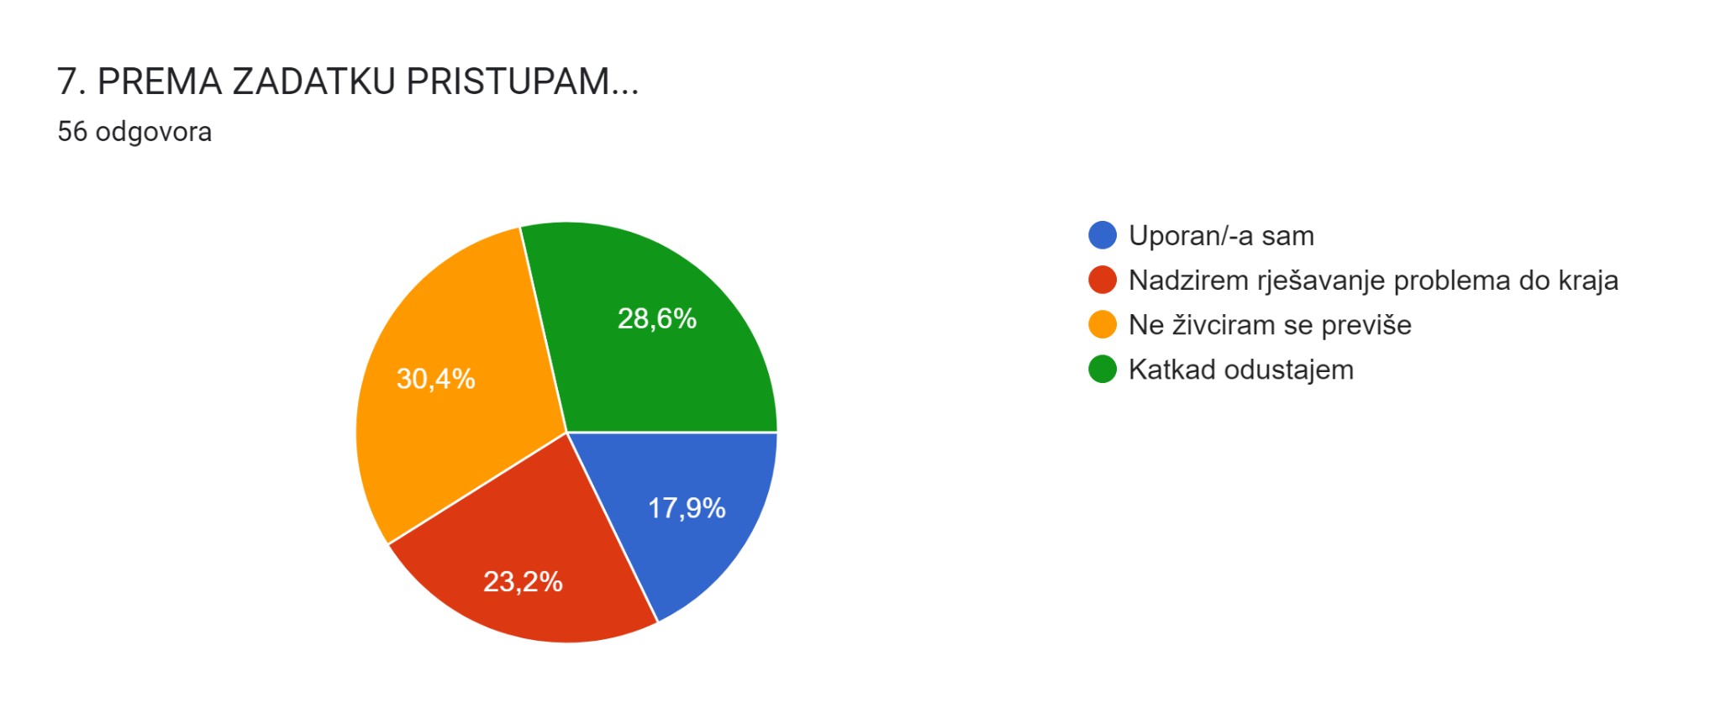[3]

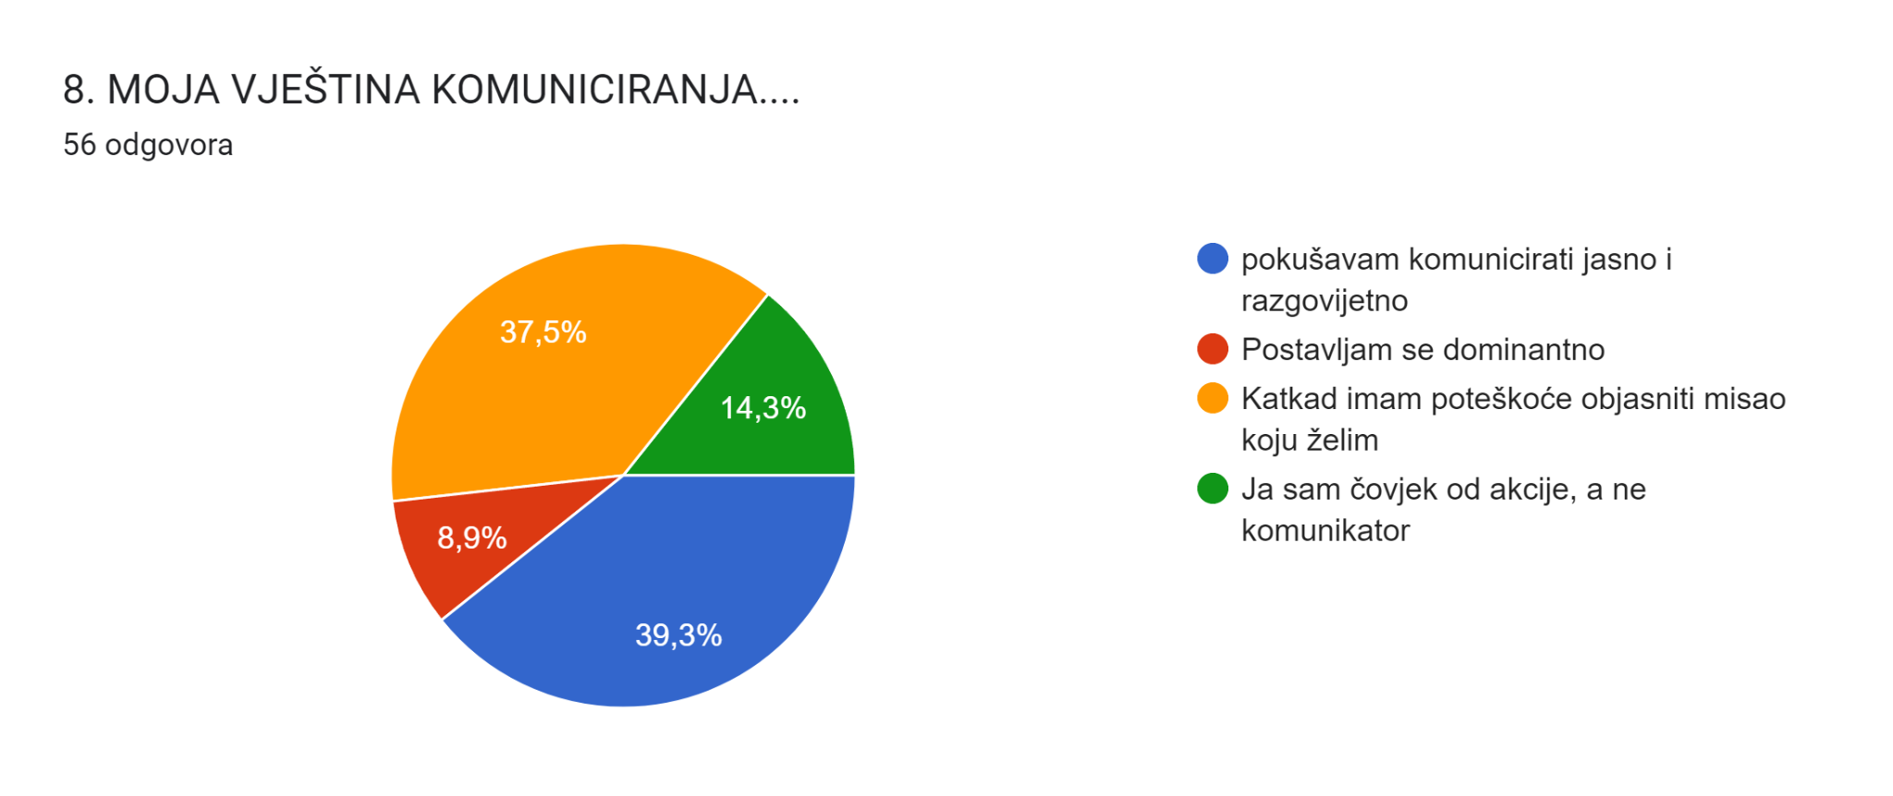

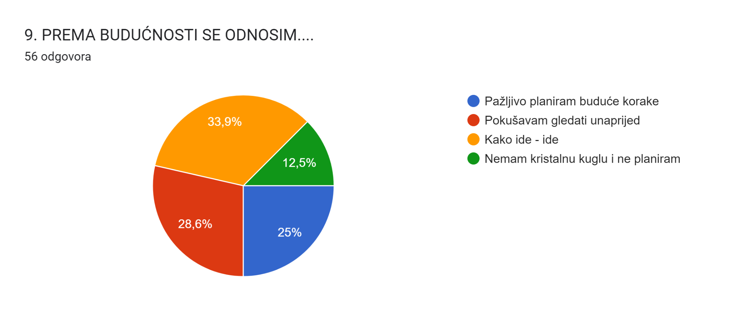

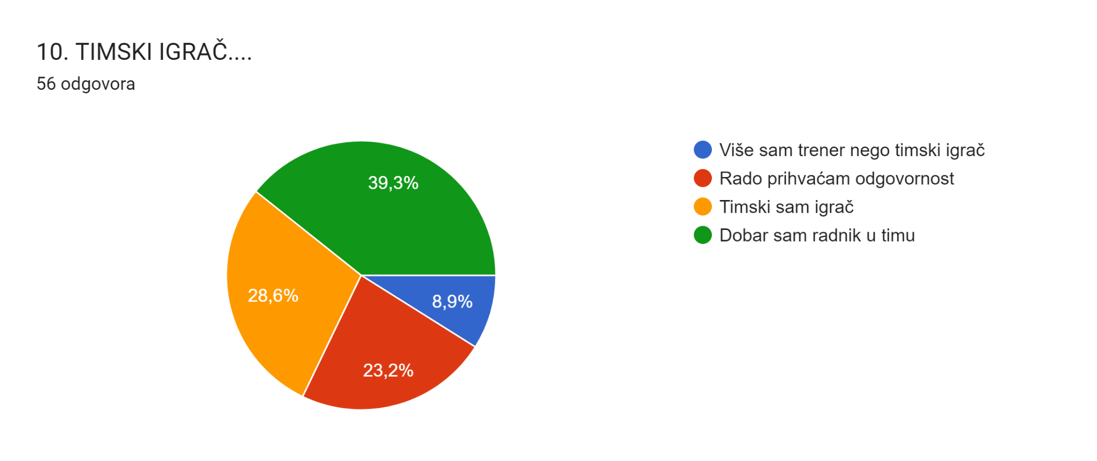[4]

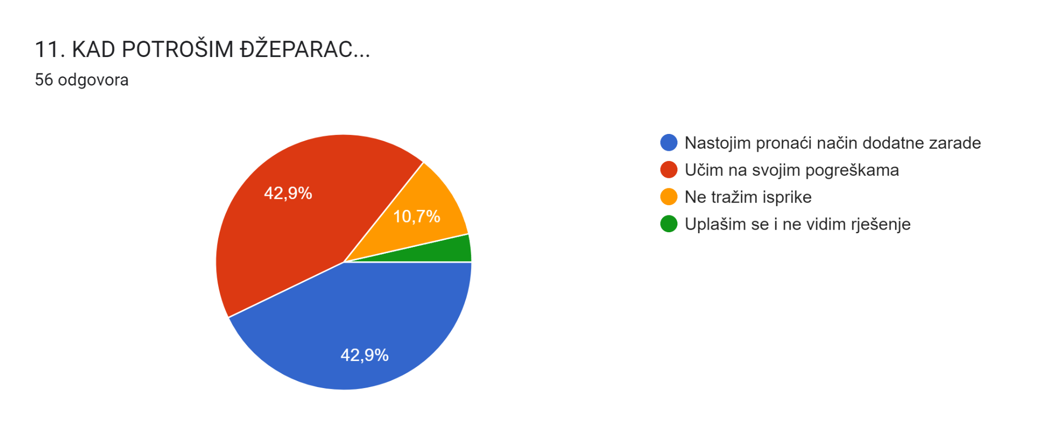

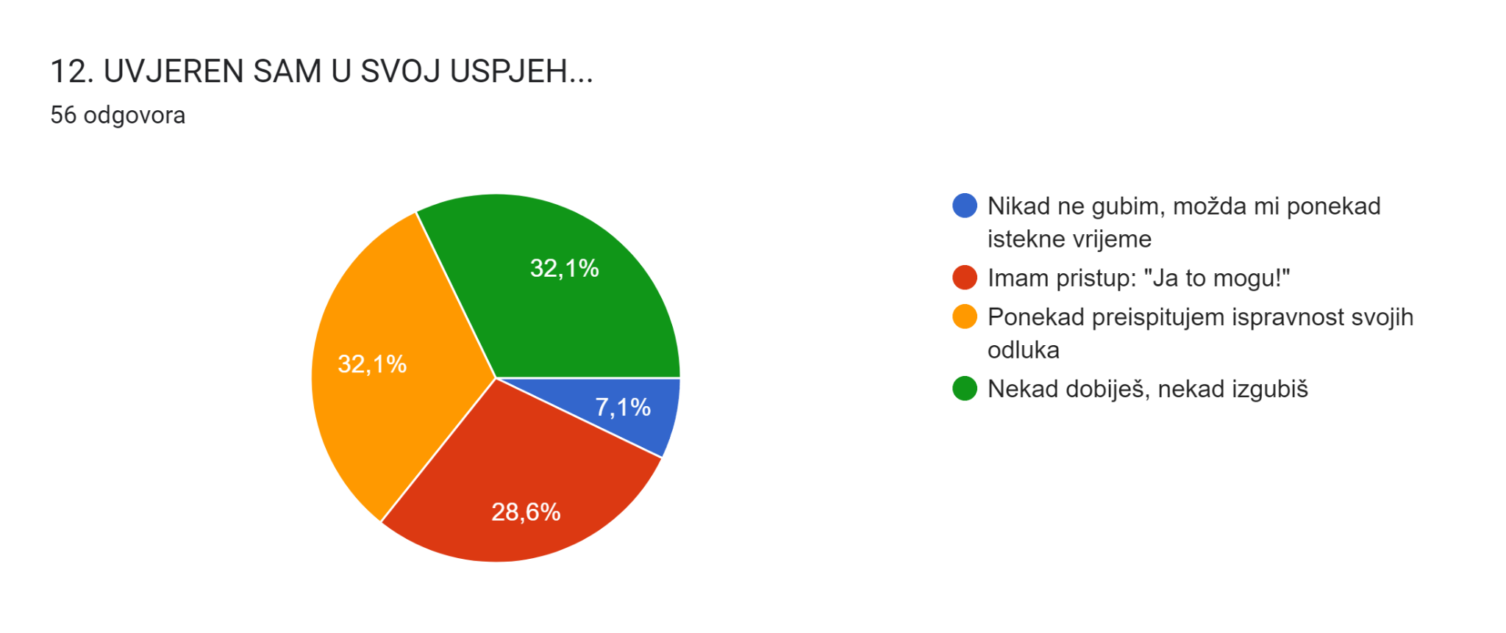

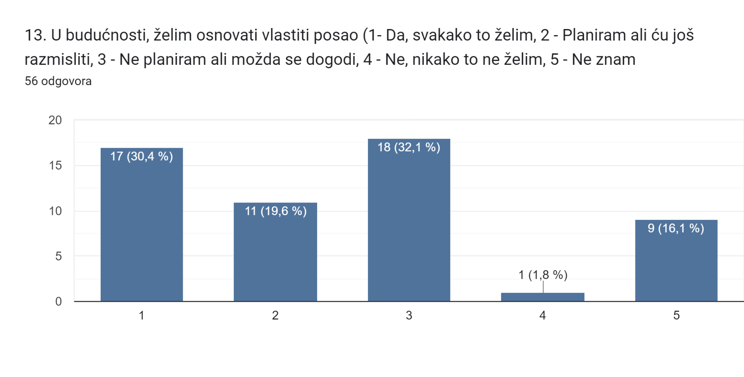[5]

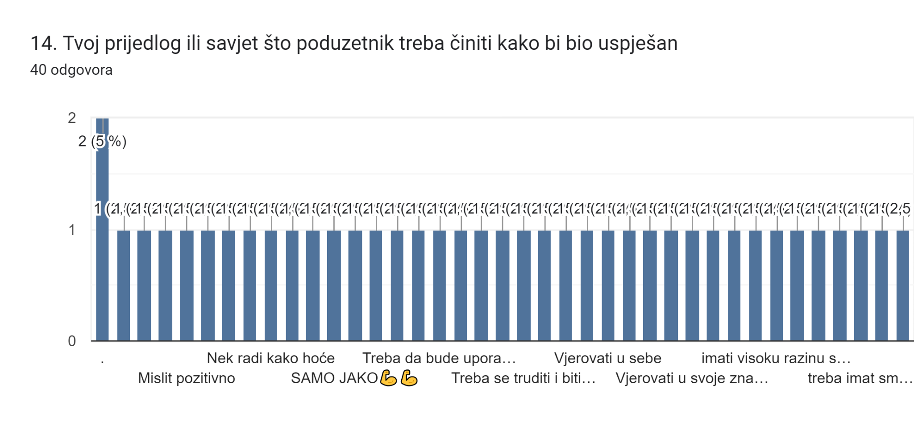

[6]

1. <https://forms.gle/sX7RoUNgyzaQBJgWA>
2. <https://forms.gle/sX7RoUNgyzaQBJgWA>
3. <https://forms.gle/sX7RoUNgyzaQBJgWA>
4. <https://forms.gle/sX7RoUNgyzaQBJgWA>
5. <https://forms.gle/sX7RoUNgyzaQBJgWA>
6. <https://forms.gle/sX7RoUNgyzaQBJgWA>